Experiment 02

AIM : Use basic networking commands in Linux (ping, traceroute, nslookup, netstat, ARP, RARP, ip, ifconfig, dig, route )

1. ping
Purpose: Tests connectivity to a host by sending ICMP echo requests.
Syntax: ping [options] destination
Example:Ping google.com

2. traceroute
Purpose: Shows the path packets take to reach a destination host.
Syntax: traceroute [options] destination
Example:Traceroute google.com

3. nslookup
Purpose: Queries DNS to find hostname or IP address information.
Syntax: nslookup [domain]
Example: nslookup google.com
4. netstat
Purpose: Displays network connections, routing tables, and interface statistics.
Syntax: netstat [options]
Example: netstat -tuln

5. arp
Purpose: Displays or modifies the system's ARP table (IP-to-MAC address mappings).
Syntax: arp [options]
Example:arp -a
6. rarp
Purpose: (Less common) Resolves IP addresses to MAC addresses in reverse; mainly used in older systems.
Note: Often replaced by arp or ip commands now.
Example: rarp -a

7. ip
Purpose: Displays/manages IP address, routing, and network interfaces.
Syntax: ip [options]
Example:ip addr show

8. ifconfig
Purpose: Configures or displays network interfaces (deprecated in favor of ip).
Syntax: ifconfig [interface]
Example:ifconfig
9. dig
Purpose: The dig command in Linux is a powerful tool for querying Domain Name System (DNS) servers. It's used to troubleshoot DNS issues, verify DNS settings, and gather information about domain names. dig stands for Domain Information Groper, and it allows users to look up various DNS records like A, MX, NS, and more.
Syntax: dig [options] domain
Example:
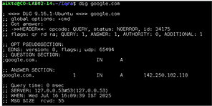

10. route
Purpose: Displays or modifies the IP routing table.The route command in Linux is used to view and manipulate the kernel's IP routing table. It allows users to display the current routing table, add new routes, and delete existing ones. While the route command is still functional, it's considered deprecated, with ip route being the recommended tool for managing routes.
Syntax: route [options]
Example:

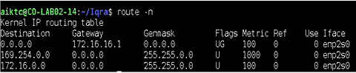
Conclusion:
Basic networking commands in Linux are essential tools for diagnosing, troubleshooting, and managing network connections. Commands like ping and traceroute help test connectivity and trace the path data takes to reach a destination. nslookup and dig are used to query DNS servers for domain name information. netstat displays active network connections and listening ports. ARP and RARP manage mappings between IP addresses and MAC addresses, helping resolve hardware addresses. The ip and ifconfig commands configure and display network interface settings. route shows and manipulates the IP routing table.
Together, these commands provide a comprehensive toolkit for understanding and controlling network behavior on Linux systems, making network management more effective and efficient.

